Mission 5 - Hovering Flight Review Questions

1 | Select the computer science definition of: MODULE | - A function that prevents the next line of code from executing until it is completed.  - Interactively enter commands in the console and view output.  - An external source of code that can be imported.  - A function that returns immediately so the next line of code can execute.
2 | Select the computer science definition of: BLOCKING | - A function that prevents the next line of code from executing until it is completed.  - Interactively enter commands in the console and view output.  - An external source of code that can be imported.  - A function that returns immediately so the next line of code can execute.
3 | Select the computer science definition of: NON-BLOCKING | - A function that prevents the next line of code from executing until it is completed.  - Interactively enter commands in the console and view output.  - An external source of code that can be imported.  - A function that returns immediately so the next line of code can execute.
4 | Select the computer science definition of: REPL | - A function that prevents the next line of code from executing until it is completed.  - Interactively enter commands in the console and view output.  - An external source of code that can be imported.  - A function that returns immediately so the next line of code can execute.
5 | Which CodeAIR sensor is used for tracking and holding position? | - Pressure sensor  - Laser rangers  - Optical flow sensor  - Light sensor
6 | What must be included in your code to call the button_arm() function | - def button_arm():  - from safety import *  - from codeair import *  - while True:
7 | What is CodeAIR’s distance measured with? | - Inches  - Feet  - Centimeters  - Meters
8 | What is a key component for keeping the drone flying at a desired altitude? | - Laser rangers  - Pressure sensor  - Optical flow sensor  - Light sensor
9 | What function reads the laser rangers? | - data(RANGERS)  - rangers.data()  - get_data(RANGERS)  - rangers.read()
10 | What line of code unpacks the tuple returned by get_data()? | - get_data.unpack()  - fwd, up, down = get_data()  - get_data() = fwd, up, down  - (fwd, up, down) = get_data()
11 | What is the result of the code?  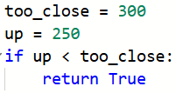 | - True is returned  - False is returned  - Nothing happens  - The program stops
12 | What is the result of the code?  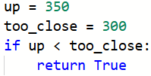 | - True is returned  - False is returned  - Nothing happens  - The program stops
13 | What is the purpose of the code?  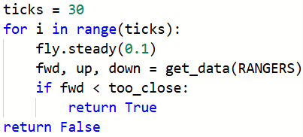 | - Hover at the given distance  - Set the sensors every tenth of a second  - Read the sensors every tenth of a second  - Poll the flight controller every tenth of a second
14 | If fwd is less than 300, what is the result of the code?  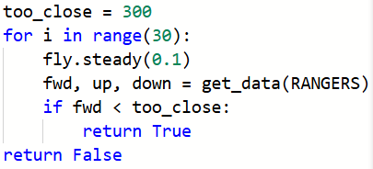 | - True is returned  - False is returned  - Nothing happens  - The program stops
15 | What code will cause a continuous speaker beep? | - speaker.beep(440)  - speaker.beep(440, 100)  - speaker.beep(440, 0)  - speaker.on()
16 | What will print after this code runs?  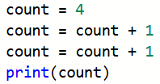 | - 4  - 5  - 6  - An error occurs
17 | What will print after this code runs?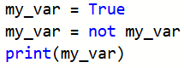 | - True  - False  - my_var  - An error occurs
18 | Which function is non-blocking? | - fly.steady(seconds)  - fly.take_off(altitude)  - fly.start_forward()  - fly.forward(distance, velocity)
19 | What is the result of the code?  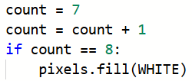 | - All pixels are turned WHITE  - Nothing happens  - All pixels are turned off  - The program stops
20 | What function turns off all blue LEDs? | - leds.set_off()  - leds.set(0)  - leds.set(BLACK)  - leds.set_mask(0, 0)

